

RAMANUJAN COLLEGE

UNIVERSITY OF DELHI

SOUTH CAMPUS IN KALKAJI 110019

PRACTICAL FILE

COMPUTER GRAPHICS

Submitted By: Yuvraj Singh

Examination Roll Number: 23020570056

Class Roll Number: 20231471

Submitted to: Dr. Aakash

Index

|  |  |  |  |
| --- | --- | --- | --- |
| S.NO. | Practical | Page No. | Signature |
| 1 | Write a program to implement Bresenham's line drawing algorithm. | 4 |  |
| 2 | Write a program to implement a midpoint circle drawing algorithm. | 5 |  |
| 3 | Write a program to clip a line using Cohen and Sutherland line clipping algorithm. | 7 |  |
| 4 | Write a program to clip a polygon using Sutherland Hodgemann algorithm. | 9 |  |
| 5 | Write a program to fill a polygon using the Scan line fill algorithm. | 12 |  |
| 6 | Write a program to apply various 2D transformations on a 2D object (use homogeneous Coordinates). | 14 |  |
| 7 | Write a program to apply various 3D transformations on a 3D object and then apply parallel and perspective projection on it. | 16 |  |
| 8 | Write a program to draw Hermite Bezier curve. | 21 |  |

# ***Acknowledgment***

**I would like to express my sincere gratitude to my instructor, DR. Aakash, for providing me with the opportunity to work on this series of practical. Their invaluable guidance and support have been instrumental in understanding the core concepts of computer graphics.**

**I would also like to thank Ramanujan College, University of Delhi, for offering such a rich curriculum that fosters technical learning and hands-on experience. The practical applications of various algorithms and transformation techniques have deepened my knowledge in the field.**

**Furthermore, I would like to thank my peers for their encouragement and collaboration during the course of this project. Their inputs have enhanced my learning experience and contributed to a stimulating environment for problem-solving.**

**Q1. Write a program to implement Bresenham’s line drawing algorithm.**

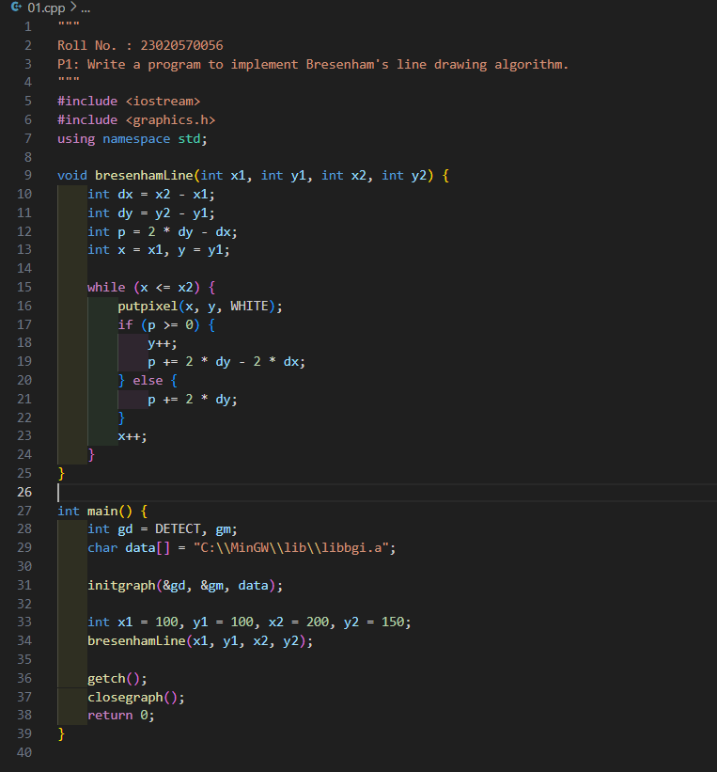

**Output:**

**Q2. Write a program to implement a midpoint circle drawing algorithm.**

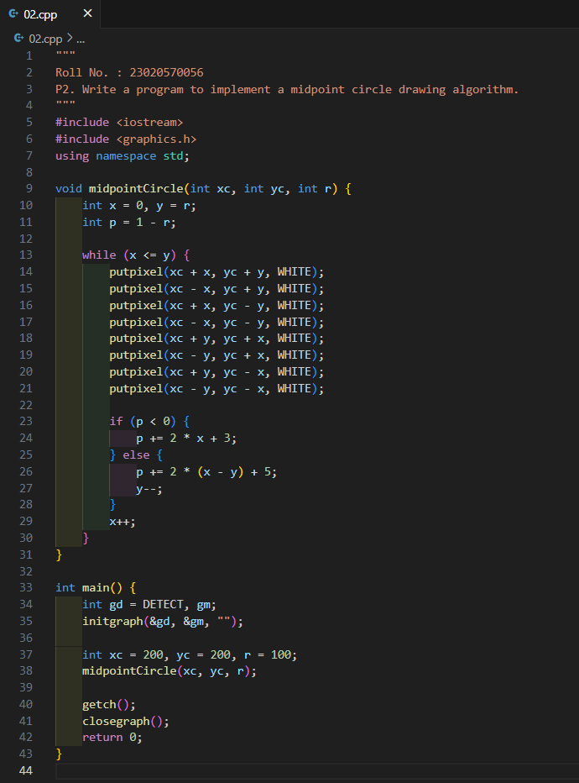

**Output:**

**Q3. Write a program to clip a line using Cohen and Sutherland line clipping algorithm.**

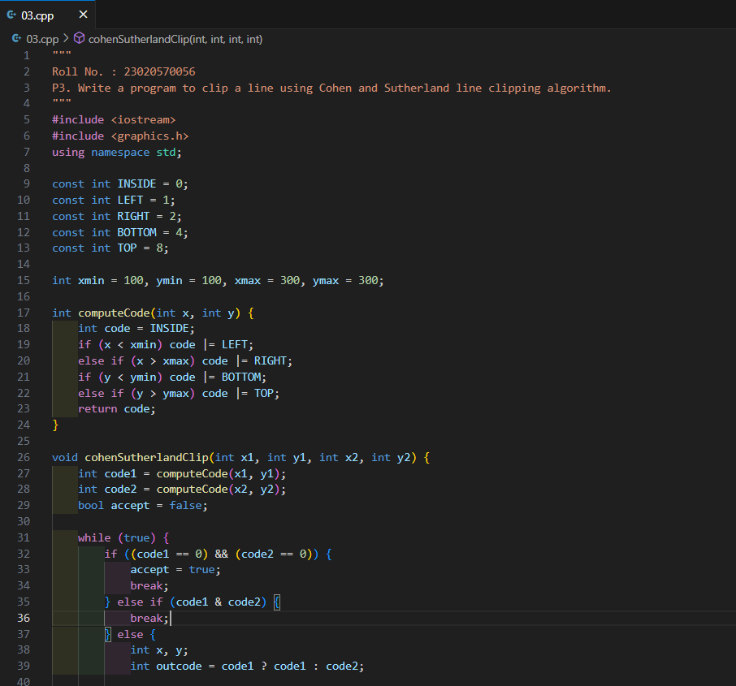

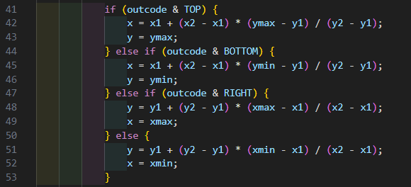

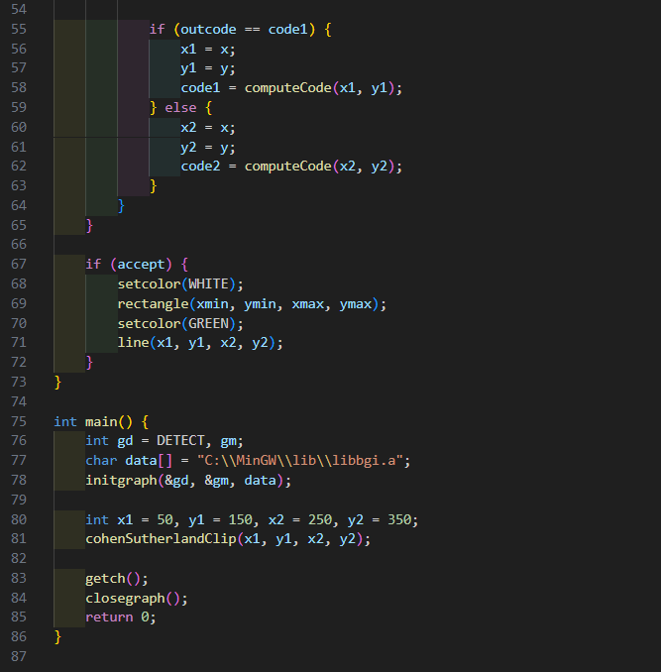

**Output:**

**Q4. Write a program to clip a polygon using Sutherland Hodgemann algorithm.** 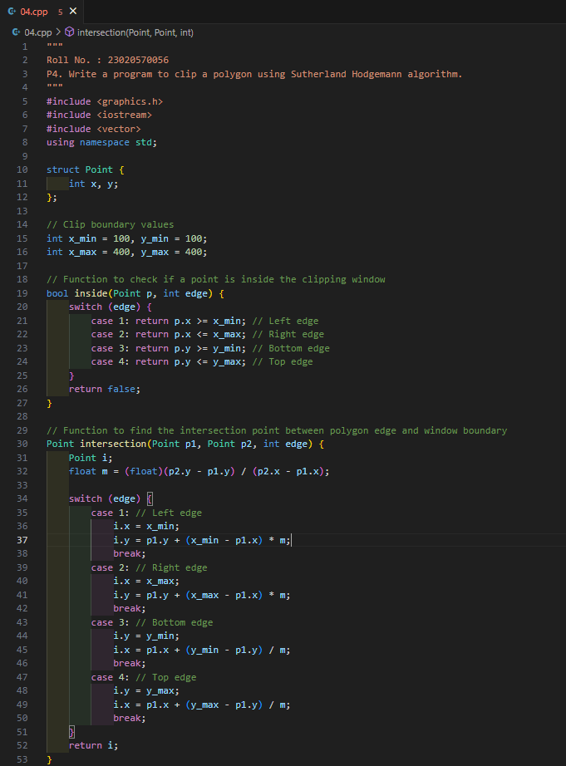

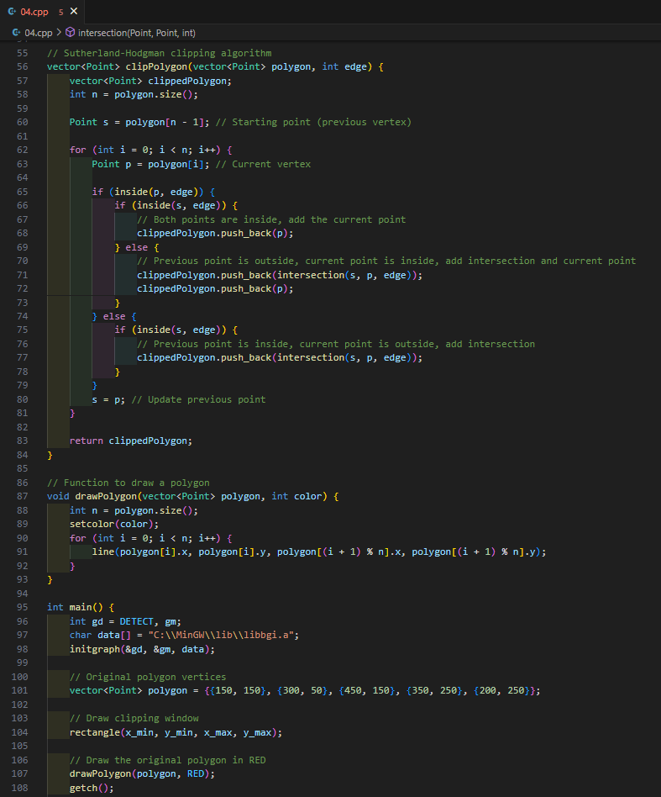 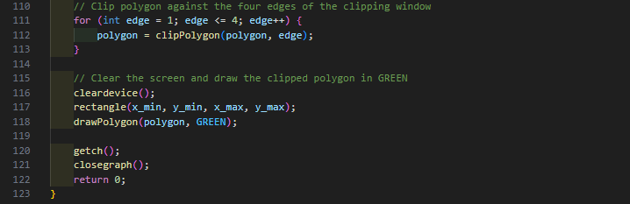

**Output:**

**Q5. Write a program to fill a polygon using the Scan line fill algorithm.**

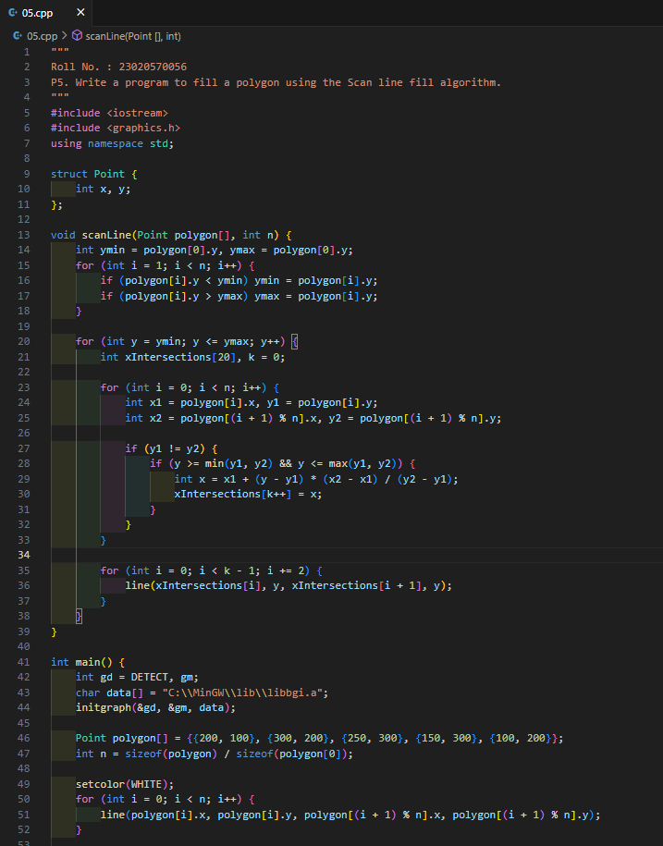 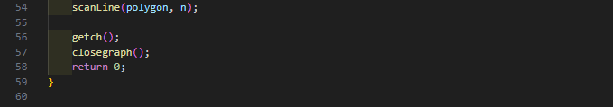

**Output:**

**Q6. Write a program to apply various 2D transformations on a 2D object (use homogeneous Coordinates).**

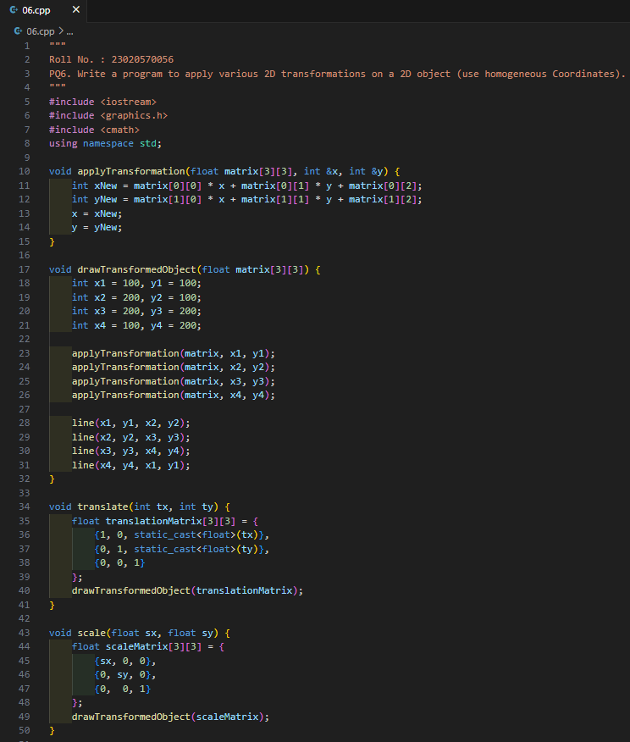

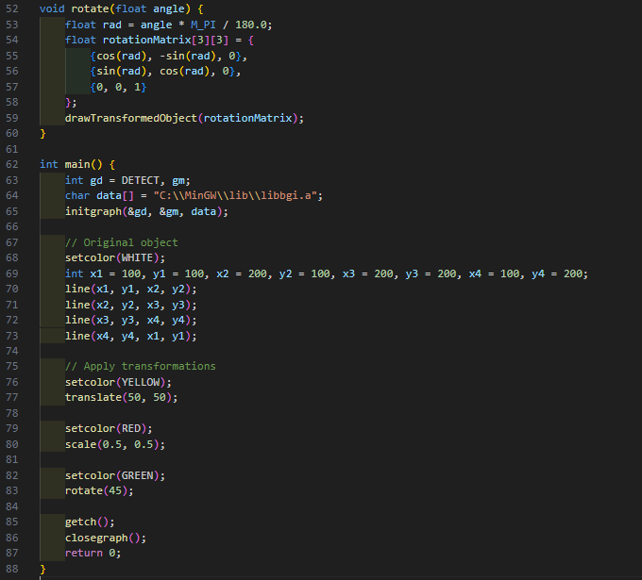

**Output:**

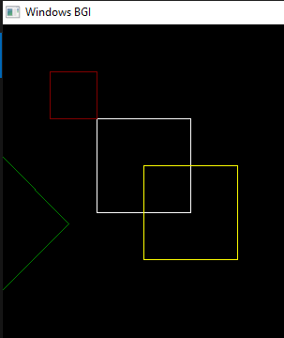

**Q7.Write a program to apply various 3D transformations on a 3D object and then apply parallel and perspective projection on it.**

1. **Parallel Projection**

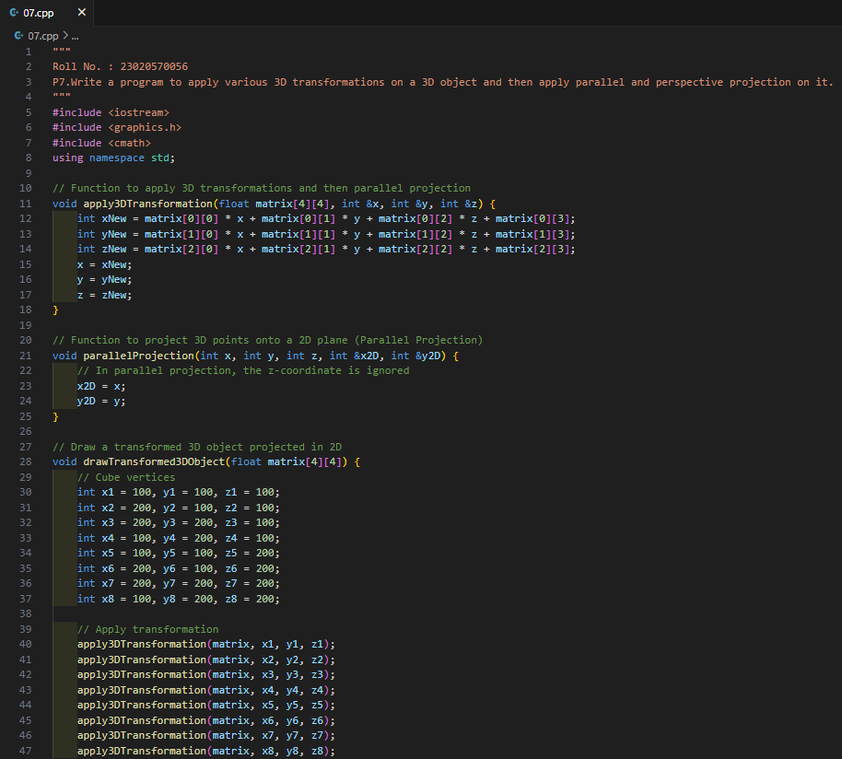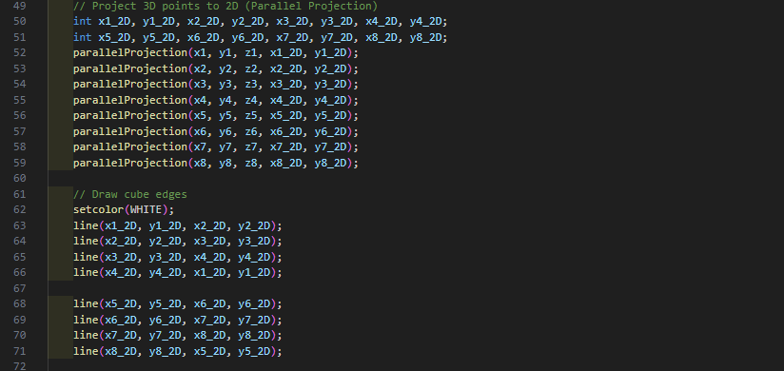

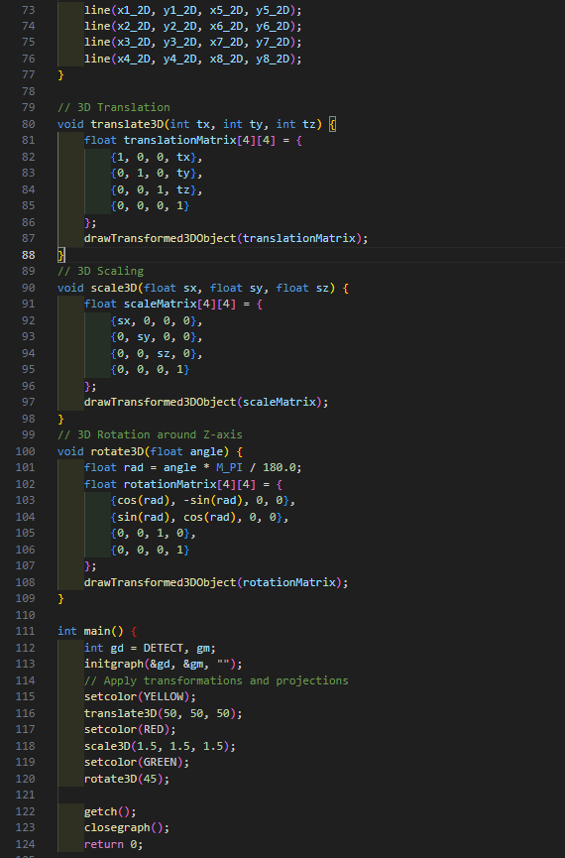

**Output:**

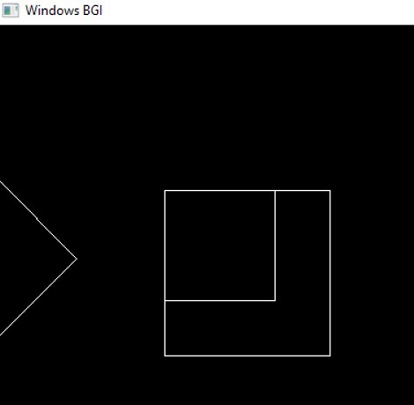

1. **Perspective Projection**

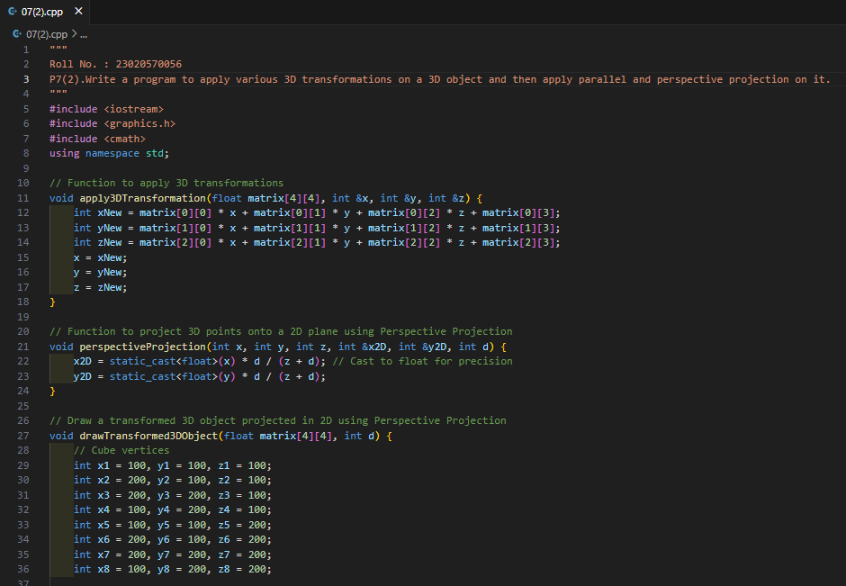

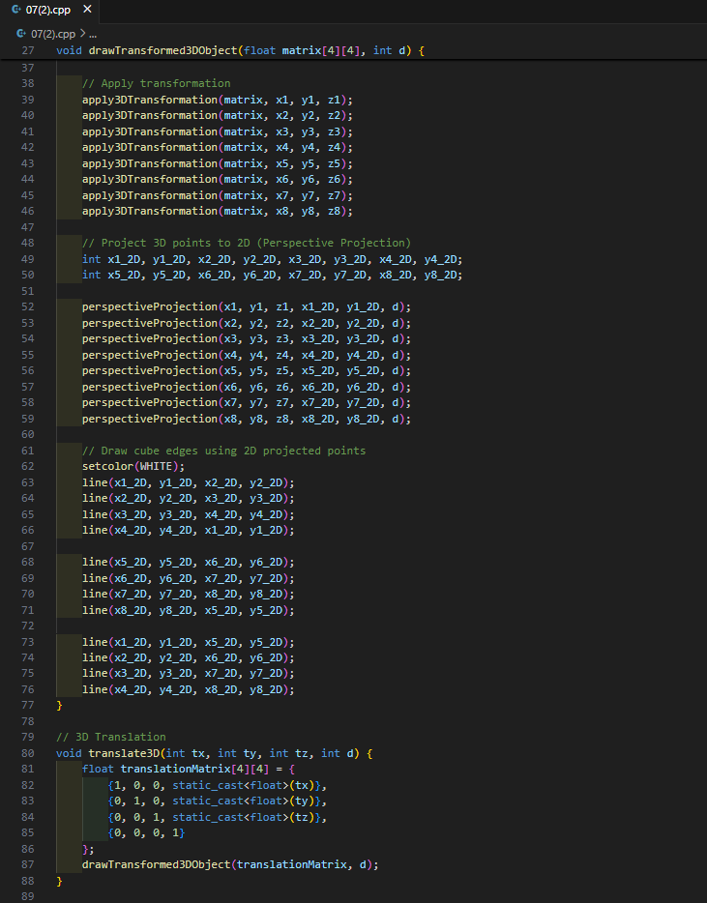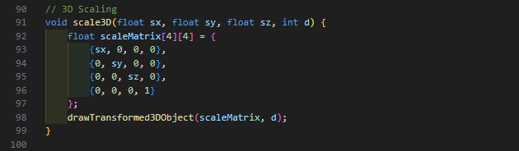

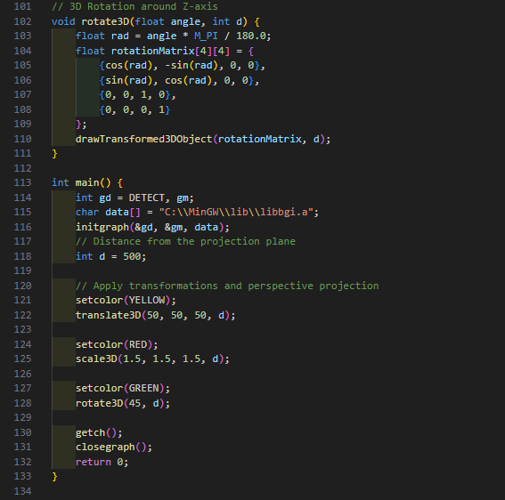

**Output:**

**Q8. Write a program to draw Hermite /Bezier curve.**

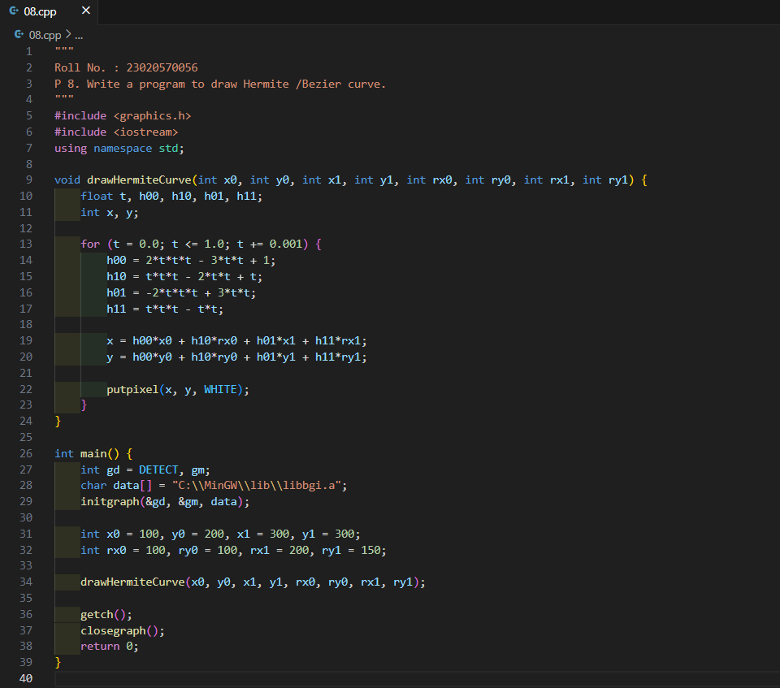

**Output:**

